KING JAMES I ACADEMY
PE BULLETIN
Ms J Humble July 2026

Athletics

Students from King James represented the Academy at two different athletics events held at Sunnydale Leisure Centre. Year 9/10 participated on the 16th June and Year 7/8 on the 23rd June. Due to not being able to take full teams there were no team results but there were some fantastic individual performances including Isreal Olabode winning his events in the 400m, high jump and relay. Jenson Wright won the 200m and was also part of the winning relay team and Eva Caygill won the shot put. Well done to all competitors!
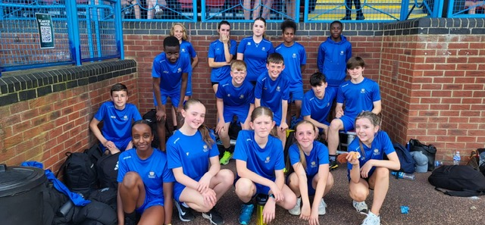

Sports Day

Year groups sports days took place this term on the 13th and 14th July. Every form class were given the opportunity to have a representative to compete in a range of athletics events. Events included track; 100m, 200m, 400m, 800m, throws; javelin, discus and shot put and jumps; standing triple and broad jump.
Students and staff were enthusiastic about the day and participated to an excellent standard with several school records being broken on the day. Well done to all competitors but a special well done to the winning form class in each year group.

Year | Points | Position | Tutor
7 | 114 | 1 | JFE
8 | 116 | 1 | JFR
9 | 131 | 1 | CAR
10 | 122 | 1 | MDI

A special well done to 10 MDI who won the year 10 sports day, it was their last sports day and they used grit and determination to overcome the other competitors.
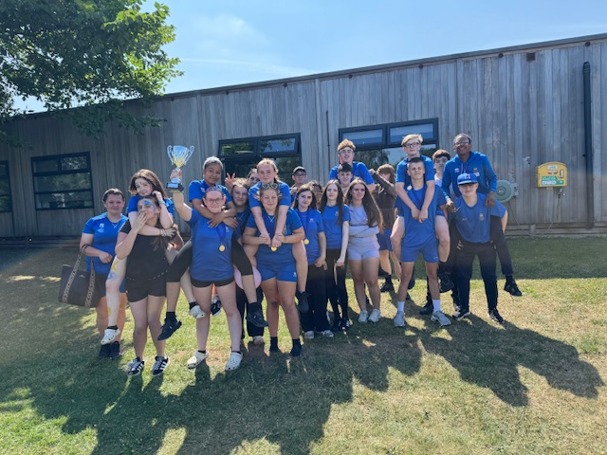

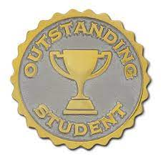
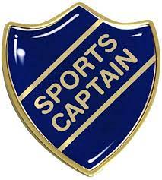

KS3 Curriculum (Sept – Oct)

GIRLS – Baseline Assessments, Netball and Hockey.
BOYS – Baseline Assessments, Football and Volleyball.

Student of the Term

Each PE teacher nominated a student for summer student of the term. Congratulations to these students.

Year 7 Boys – Nisar Rahime
Year 7 Girls – Isabella Fantin
Year 8 Boys – Jenson Wright
Year 8 Girls – Aimee Jones
Year 9 Boys – Wade Jefferson
Year 9 Girls – Tallulah Hope
Year 10 Boys – Clarence Masara
Year 10 Girls – Olivia Bowskill
Sixth From – Fahryn Brown

