KING JAMES I ACADEMY
PE BULLETIN
Ms J Humble July 2023

Athletics

Students from King James represented the Academy at two different athletics events held at Sunnydale Leisure Centre. Year 9/10 participated on the 22nd June and Year 7/8 on the 13th June. Year 9 boys won the team event beating 6 other schools to become overall winners. There were also some fantastic individual performances including Briar Rose Howard winning the 200m in a PB and school record, Jackson Raitt getting school records in the 8oom and the discus and Fahryn Brown winning the javelin for his year group. Well done to all competitors.

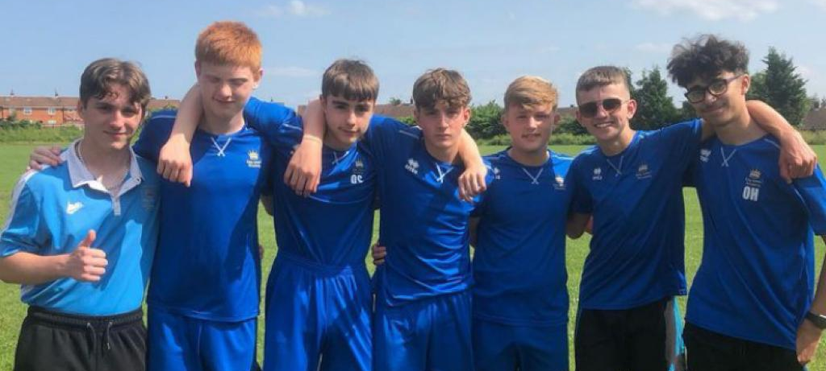

Sports Day

Year group sports days took place this term on the 17th and 18th July. Every form class were given the opportunity to have a representative to compete in a range of athletics events. Events included track 100m, 200m, 400m, 800m, throws; javelin, discus and shot putt and jumps; standing triple and broad jump.
Students and staff were enthusiastic about the day and participated to an excellent standard with several school records being broken on the day. Well done to all competitors but a special well done to the winning form class in each year group.

Year | Points | Position | Tutor
7 | 127 | 1st | RGR
8 | 118 | 1st | GCR
9 | 130 | 1st | SFO
10 | 84 | 1st | JHO  MJS  DRI

It was year 10’s last sports day as they will have left this time next year. So special mention to all year 10 competitors and their effort in a hard-fought competition resulting in a 3-way tie between Miss Howards, Mr Saunders and Mr Riley’s form classes. In addition, well done to Miss Howard for competing for her form, we love the commitment and dedication!

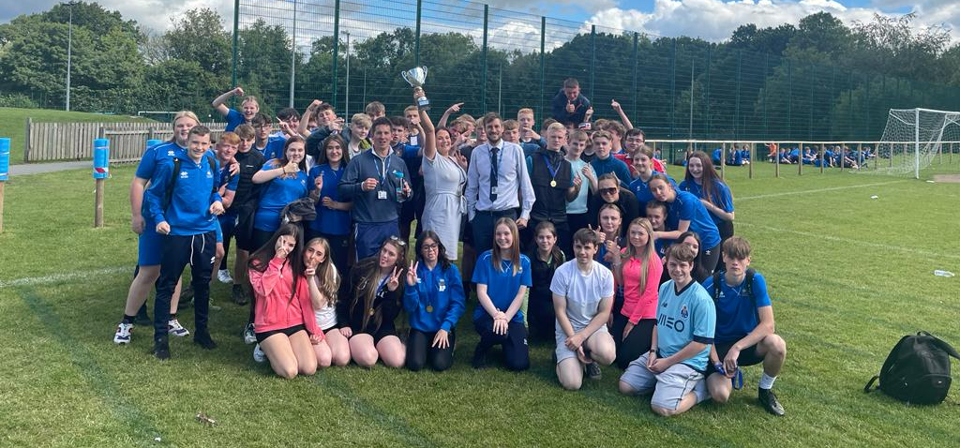



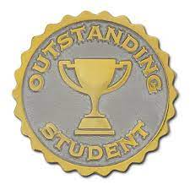

Student of the Term

Each PE teacher nominated a student for summer student of the term. Congratulations to these students.

Year 7 Boys – Frederic Doidge
Year 7 Girls – Elexi Rowlands
Year 8 Boys – Lleyton Martin
Year 8 Girls – Scarlett Blenkinsopp
Year 9 Boys – Oliver Smith
Year 9 Girls – Sophie Pickford
Year 10 Boys – Mason Jay Wright
Year 10 Girls – Amber Roe
Sixth From – Katie Rutherford

KS3 Curriculum (Sept – Oct)

GIRLS – Baseline Assessments, Netball and Hockey.
BOYS – Baseline Assessments, Football and Volleyball.

