KING JAMES I ACADEMY
PE BULLETIN
Ms J Humble July 2022

Athletics

Students from King James represented the Academy at two different athletics events held at Sunnydale leisure centre. Year 9/10 participated on the 21st June and Year 7/8 on the 27th June. Unfortunately, we didn’t win the team events but there were some fantastic individual performances including Joji Basudra winning shot putt with a school record, Amelia Dickinson winning high jump and also winning and setting a new PB in the 800m, and Lucas Heels won the 200m for his year group. Well done to all competitors.

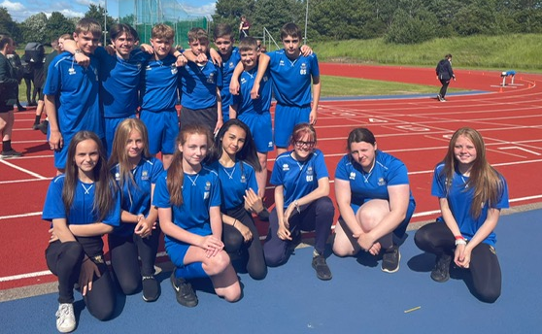

Sports Day

Year groups sports days took place this term on the 11th and 12th July. Every form class were given the opportunity to have a representative to compete in a range of athletics events. Events included track; 100m, 200m, 400m, 800m, throws; javelin, discus and shot putt and jumps; standing triple and broad jump.
Students and staff were enthusiastic about the day and participated to an excellent standard with several school records being broken on the day. Well done to all competitors but a special well done to the winning form class in each year group.

Year | Points | Position | Tutor
7 | 130 | 1st | KBL
8 | 133 | 1st | SKE
9 | 126 | 1st | DRI
10 | 94 | 1st | LWI

It was year 10’s last sports day as they will have left this time next year. So special mention to all year 10 competitors and the winning form tutor Miss Whittaker. In addition, well done to Mrs Coy, Miss Howard and Mrs Dawson for competing for their forms, we love the commitment and dedication!

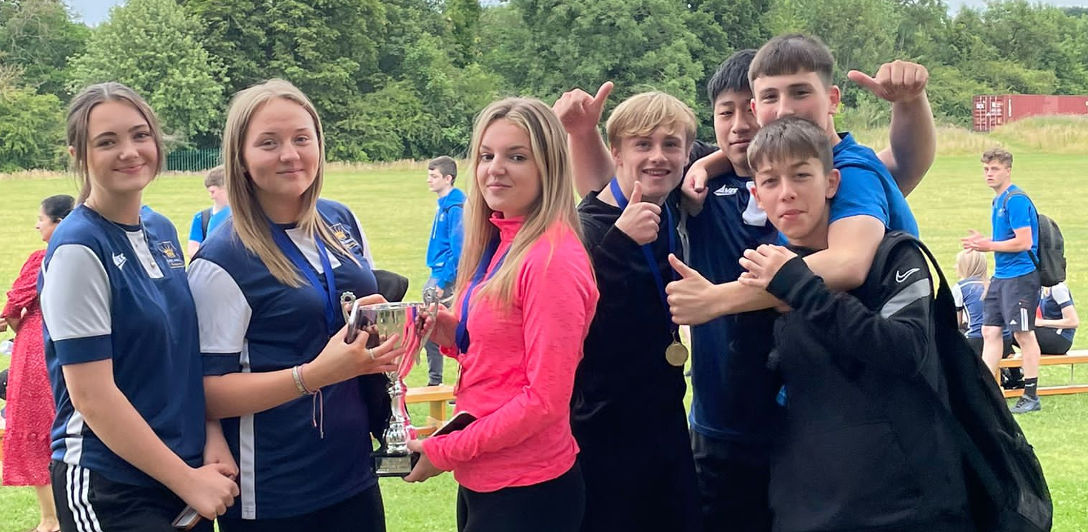




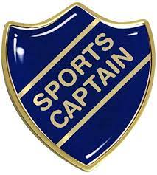
Student of the Term

Each PE teacher nominated a student for summer student of the term. Congratulations to these students.

Year 7 Boys = Adam Plews.
Year 7 Girls = Hollie Dickinson.
Year 8 Boys = Neven Lamb.
Year 8 Girls = Molly Johnson.
Year 9 Boys = James Moreland.
Year 9 Girls = Mackenzie Peate.
Year 10 Boys = Connor Williamson.
Year 10 Girls = Lilly Tinkler.
Sixth From = Aaron Ross.

KS3 Curriculum (Sept – Oct)

GIRLS – Baseline Assessments, Netball and Hockey.
BOYS – Baseline Assessments, Football and Volleyball.

