KING JAMES I ACADEMY
PE BULLETIN
Ms J Humble December 2024

Football
King James football teams have played a number of fixtures with mixed results.
Year 7 Football Team; Lost 10-4 against St Johns. Lost 8-3 against Sedgefield. Lost 7-1 against Durham Johnston. Drew 1-1 against Woodham. Lost 5-2 against Whitworth.
Year 8 Football Team; Won 3-2 against St Johns. Lost 2-1 against Sedgefield. Lost 3-2 against Whitburn (County Cup). Won 5-3 against Park View (County Cup). Lost 14-1 against Durham Johnston. Lost 5-0 against Woodham. Lost 10-0 against Whitworth.
Year 9 Football Team; Lost 2-1 against St Johns. Drew 2-2 against Sedgefield. Lost 8-0 against Durham Johnston. Lost 8-1 against Whickham (County Cup). Lost 4-1 against Woodham.
Year 10 Football Team; Lost 13-1 against St Johns. Lost 5-2 against Sedgefield.
Year 11 Football Team; Drew 2-2 against Wolsingham and then beat them on penalties (League Cup). Beat Dyke House 3-1 in the County Cup. Drew 2-2 against Emmanuel College and then beat them on penalties (County Cup). Beat Bishop Barrington 2-0 (League Cup Quarter-Final).
Well done to all students who have represented the academy.
Fixtures recommence after the Christmas break
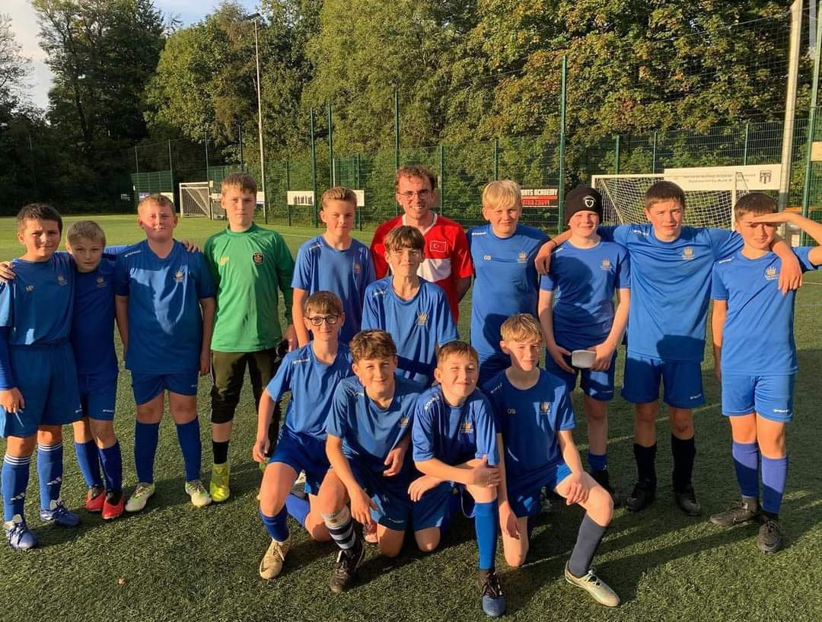

Yr7/8 Girls Football

The year 7 and 8 girls football team competed in the secondary school games against five local schools on the 4th October 2024. They were undefeated throughout the tournament and were crowned overall winners. Well done to the team who have played well as a new team and we hope to build on their success in the future.

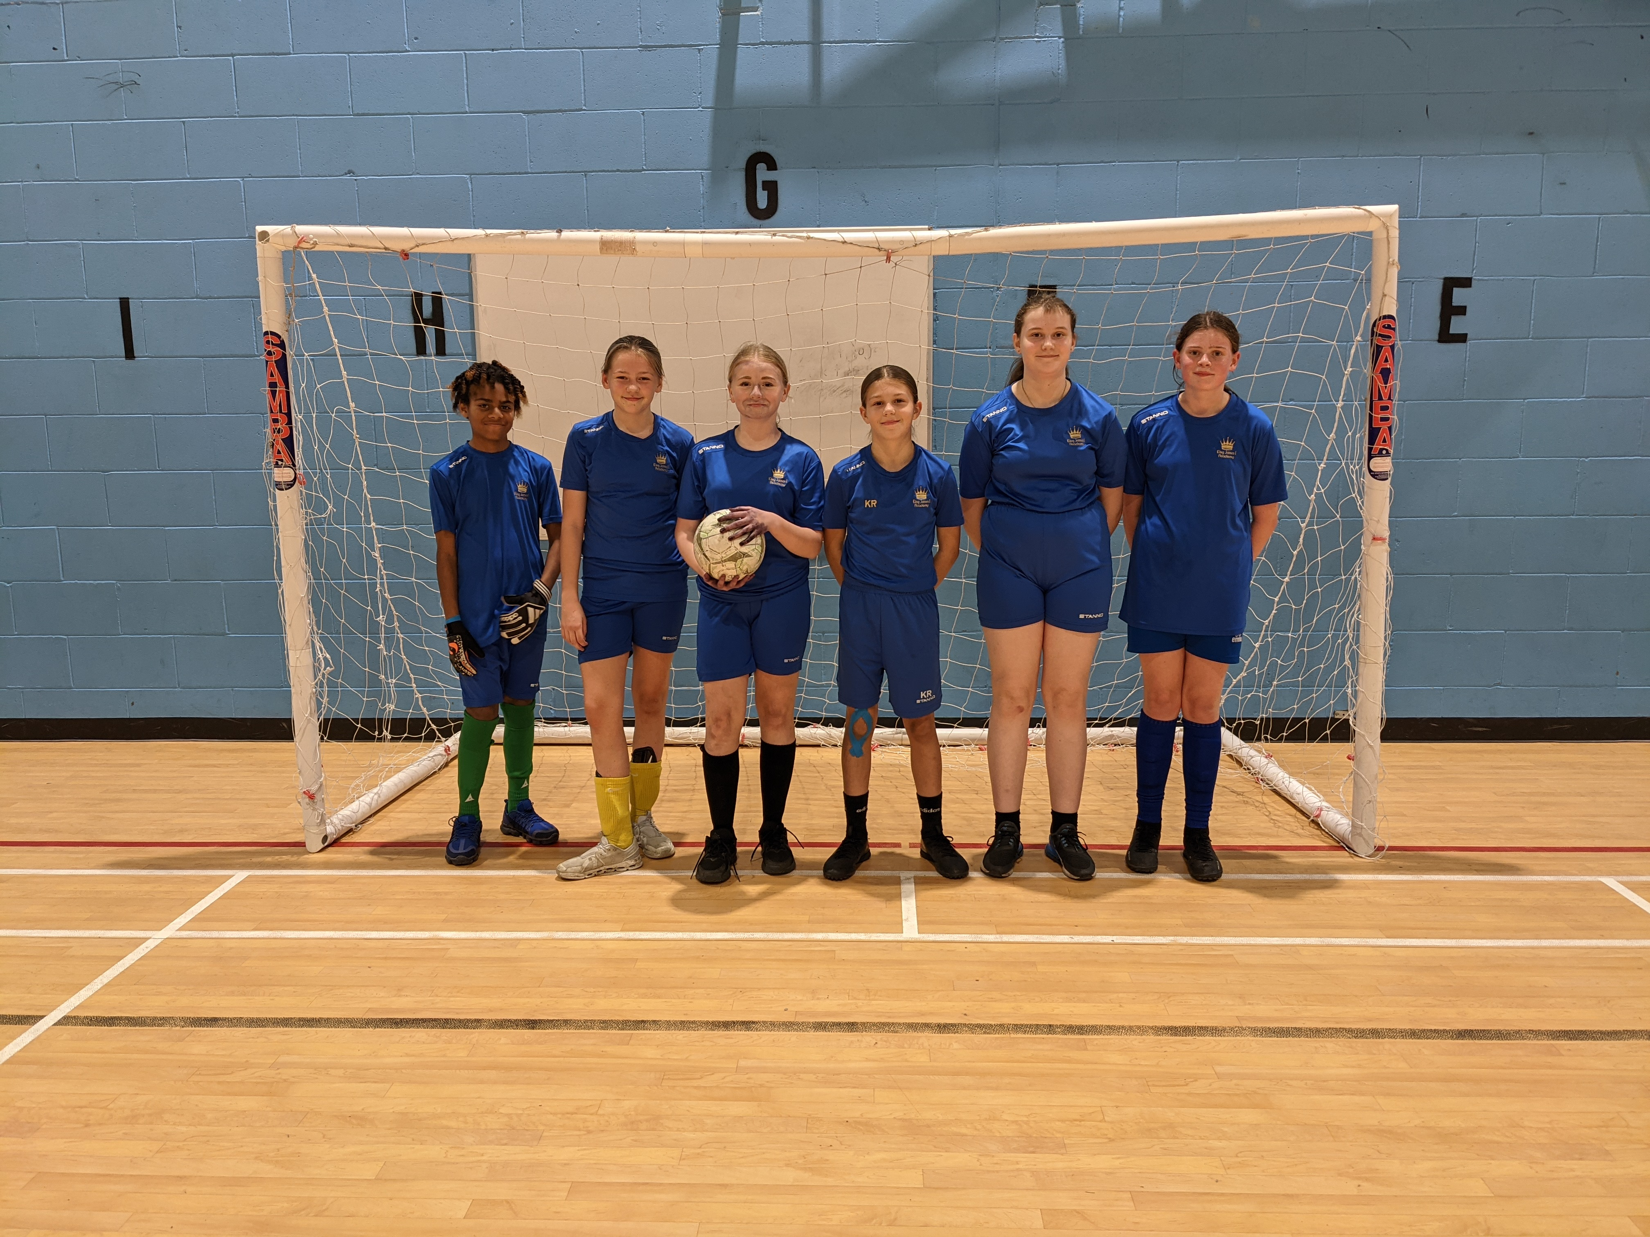

Student of the Term

Each PE teacher nominated a student for Autumn student of the term. Congratulations to these students.

Year 7 Boys – Sebastian Coulthard
Year 7 Girls – Jessica Woolfe
Year 8 Boys – Jayden Atkinson
Year 8 Girls – Maisy Timms
Year 9 Boys – Bradley Brownson
Year 9 Girls – Kaitlyn Ballan
Year 10 Boys – Kenzie Watson
Year 10 Girls –. Alisha Garrett
Year 11 Boys – Justin Fitt
Year 11 Girls – Brooke Jardine
Year 12 – Fahryn Brown

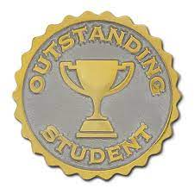

KS3 Curriculum (Jan-Mar)

GIRLS – Trampolining, Badminton, Dance and Tag Rugby.
BOYS – Trampolining, Badminton and Fitness.

Cross – Country Championships

The district cross country championships took place at Barnard Castle. Top 16 finishers would earn their place in the county championships which will be held in January. Qualifers for the county team are -Year 7 boys - Charlie Harper (5th), Nathan Lawton (8th) and Tyler Fieldson (12th). Year 7 girls - Gracie Slater (6th) and Jessica Woolfe (15th). Year 8 girls - Kaitlyn Rutherford (14th). Year 8 boys - Kaidon Hallimond (10th). Well done to these students and all competitors who represented the academy.

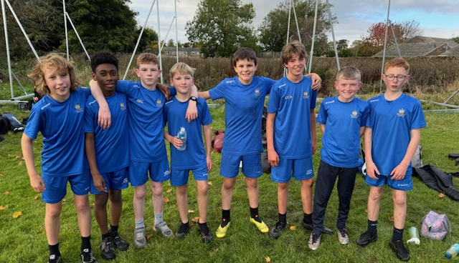
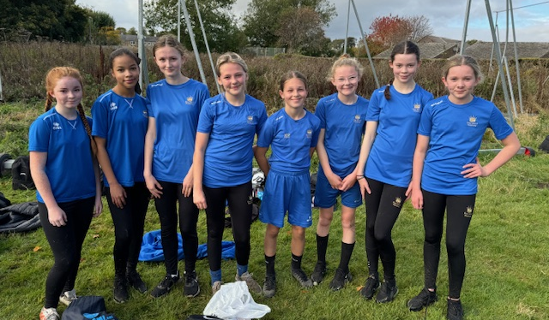

Year 10 / 11 Netball

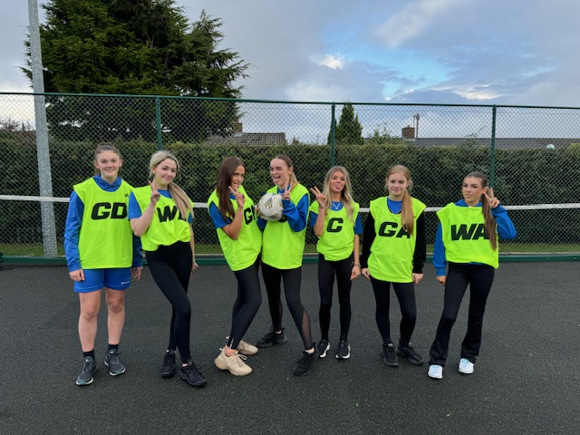
Year 10 / 11 have been competing in tournaments throughout Autumn term. They have played a number of matches with mixed results. Results worth a mention are a 1–1 draw with St Johns, a victory over local rivals Barrington 3-1 and beating Staindrop 2–0. The girls also got footage for their GCSE practical assessment and BTEC PSA. Well done to all competitors.

Year 7 Badminton

Our year 7 players competed against other students from five local schools on the 4th October 2024. We finished second overall in the event.

Year 7/8 Indoor Athletics

Year 7 and 8 Indoor Athletics Secondary School Games took place on 15/11/24 at Barrington. Students competed in various events including relays, standing triple jump and shot putt. The teams competed well with year 7 boys finishing 5th, year 7 girls 4th, year 8 boys 3rd and year 8 girls 6th.
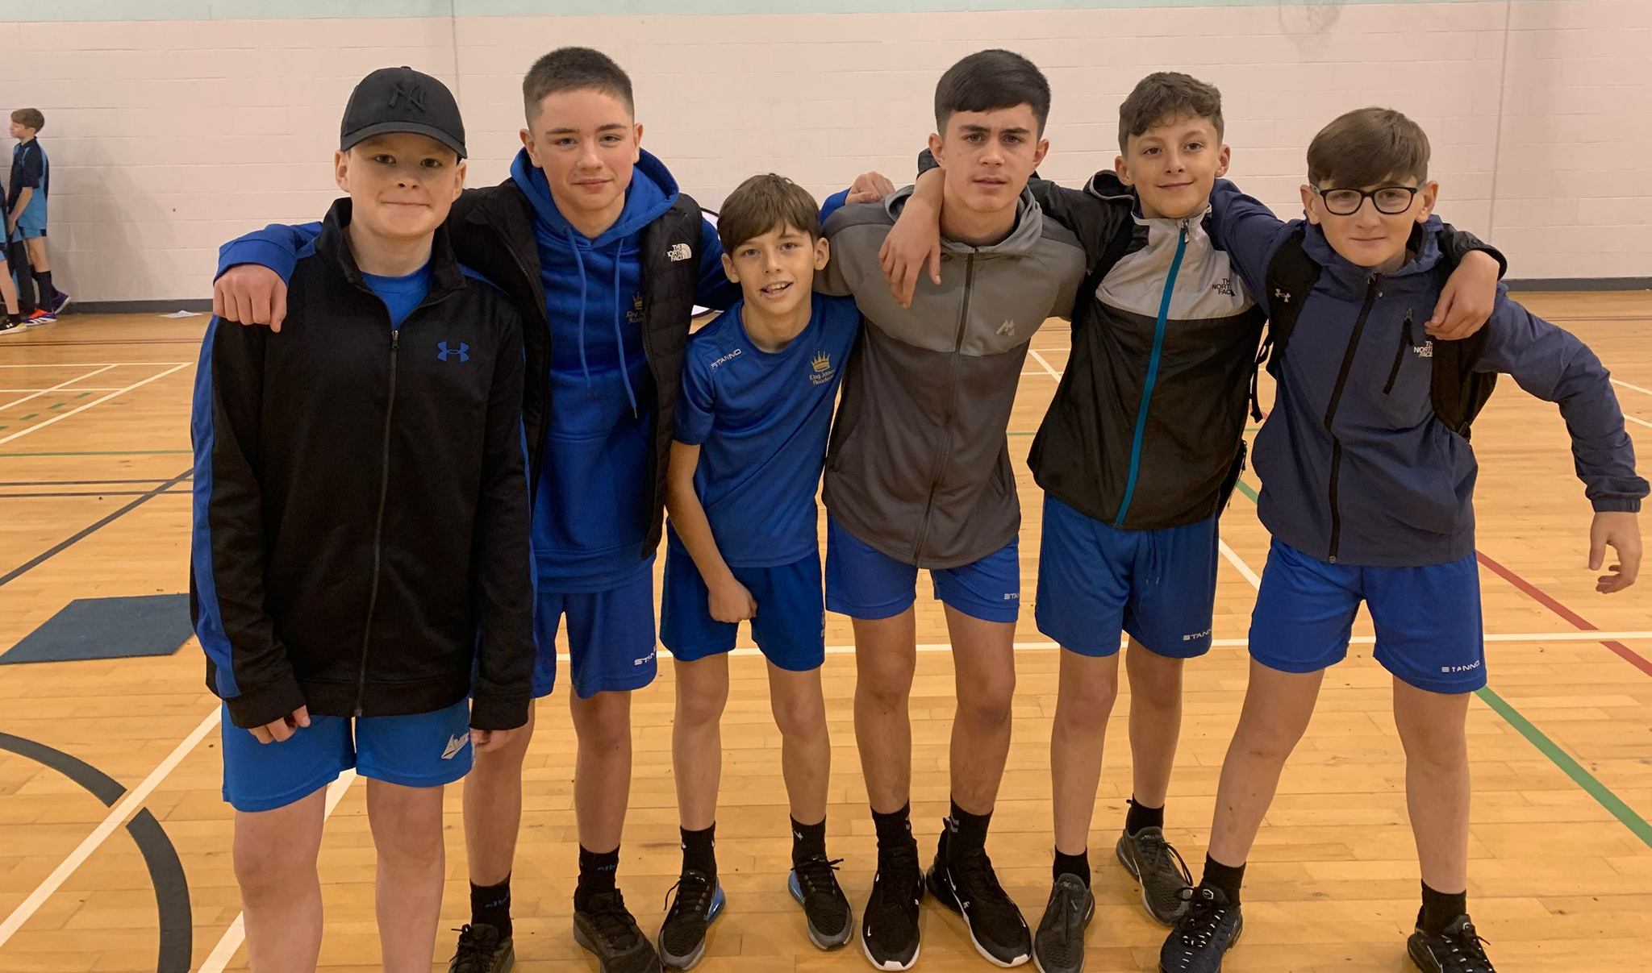

Rock Climbing
The year 11 GCSE class were taken to ROF 59 (Rock Antics) to complete their GCSE assessment in Rock Climbing. They completed various activities including bouldering, traversing, tying on, belaying and various climbs, some with a high level of difficulty. They worked hard all day and all successfully passed their assessment.
