KING JAMES I ACADEMY
PE BULLETIN
Ms J Humble April 2025

Girls Netball
Year 7 and 8 girls have competed in triangular matches and a tournament this year. Congratulations to year 7 who were unbeaten in the triangular matches and came third in the tournament but were only 2 points behind the winners. Results included a 2-0 win against Woodham, a 5-4 win against Bishop Barrington, a 7-0 win against Whitworth, a 4-1 win against Sedgefield, 5-0 win against Staindrop and a 8-7 win against St Johns. Defeats were 2-1 against Bishop Barrington and 4-2 against St Johns.
Year 8 had mixed results winning against Staindrop but losing against St Johns and Greenfield. They finished 5th in the tournament out of 10 teams
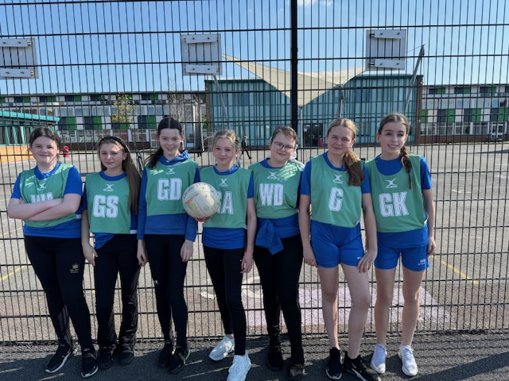

KS3 Sponsored Fun Run

Students who are attending the Holland Trip in May 2025 took part in a sponsored fun run to raise money for the trip. Students wore fancy dress and ran continuously for 30 minutes raising funds and improving their fitness.


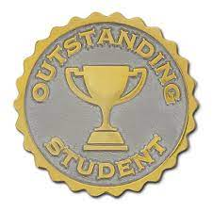
Student of the Term

Each PE teacher nominated a student for spring student of the term. Congratulations to these students.

Year 7 Girls = Darcy Aldridge
Year 7 Boys = Jenson Wright
Year 8 Girls = Sophia Newland
Year 8 Boys = Kai McGuinness
Year 9 Girls = Lilly Blacklock
Year 9 Boys = Zack Roddam
Year 10 Girls = Imogen Rothery
Year 10 Boys = Adam Plews
Year 11 Girls = Leyla Yilmaz
Year 11 Boys = Adam Vickers
6th Form = Zak Seymour

KS3 Curriculum (April - May)

GIRLS – Basketball and Athletics
BOYS – Cricket, Softball and Athletics

Boys Football
Boys football matches resumed this term after a short break.
Year 7 lost 4-1 against Woodham, 6-0 against Durham Johnston and 6-2 against St John's.
Year 8 won 5-4 against Woodham but lost 6-3 against Sedgefield and 4-0 against Durham Johnston.
Year 9 lost 3-1 against Woodham.
Year 10 lost 7-0 against Woodham
Year 11 have a cup final against Durham Johnston after the Easter holidays.

