KING JAMES I ACADEMY
PE BULLETIN
Ms J Humble April 2022

Football
King James football teams have played a number of fixtures with mixed results.
Year 11 Boys Football Team (2021-2022) lost 3-0 to Parkside.
Year 10 Boys Football Team (2021-2022) were beaten by Parkside 7-0 and lost to Durham Johnston 7-0.
Year 9 Boys Football Team (2021-2022) beat Bishop Barrington 7-2, were beaten 2-0 against Parkside and a narrow defeat to Woodham 4-3.
Year 8 Boys Football Team (2021-2022) beat Parkside 1-0 and lost to Woodham 4-1.
Year 7 Boys Football Team (2021-2022) lost narrowly to Ferryhill 6-5, lost to Parkside 6-0, lost to Durham Johnston 7-0 and lost to Woodham 7-1
Well done to all students who have represented the Academy.

Futsal

Year 10 competed in a Futsal tournament held at King James 1 Academy in February. They competed well and finished 2nd overall. Special mention to Bradley Liddell who demonstrated a high skill level and good ball control throughout.

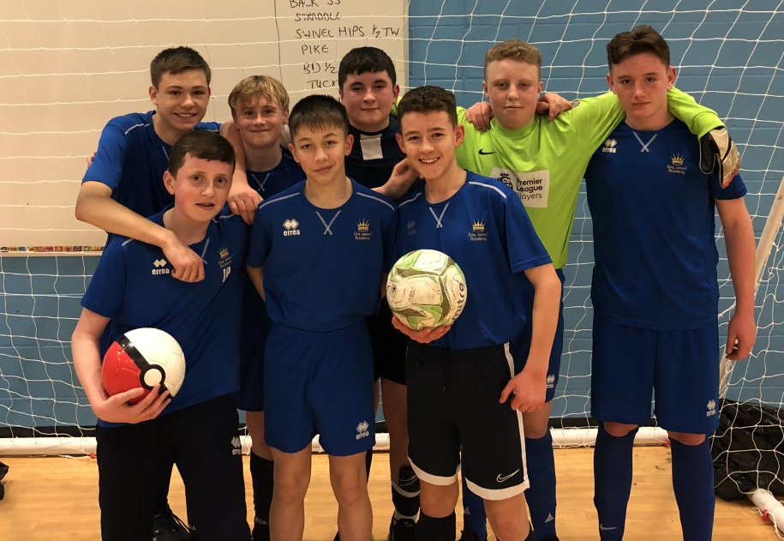

Student of the Term

Each PE teacher nominated a student for spring student of the term. Congratulations to these students.

Year 7 Girls = Ella Wiseman
Year 7 Boys = Luke Thompson
Year 8 Girls = Brooke Henry
Year 8 Boys = Reece Gargett
Year 9 Girls = Isabelle Richardson
Year 9 Boys = Lucas Heels
Year 10 Girls = Leona McDonnell
Year 10 Boys = Joji Basudra
Year 11 Girls = Katie Rutherford
Year 11 Boys = Kieran Howarth


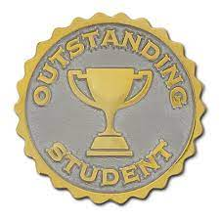
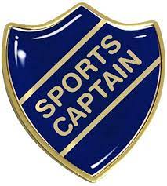

Sports Captains

Students in year 10 were given the opportunity to become sports captains. This involves supporting the PE department with primary festivals and school fixtures. Congratulations to the following students -
LWI - Katherine Smith, Ruby Sheridan and Amelia Dickinson
KEE - Leona McDonnell and Thomas Brown
EED - Dillon Allison and Lexi Hogben-Stephenson
KTA - Luke Bell and Romario Fraser
BBU - Joji Basudra and Justin Breward
DWH - Elliot Burnside and Robyn Thompson
GRA - Paige Gordon and Leah Walton-Brown
MHI - Bradley Liddle and Abbie Richardson

KS3 Curriculum (April-July)

GIRLS – Athletics, Basketball and Rounders.
BOYS – Athletics, Softball and Cricket.

